Contents
File IO

I/O streams
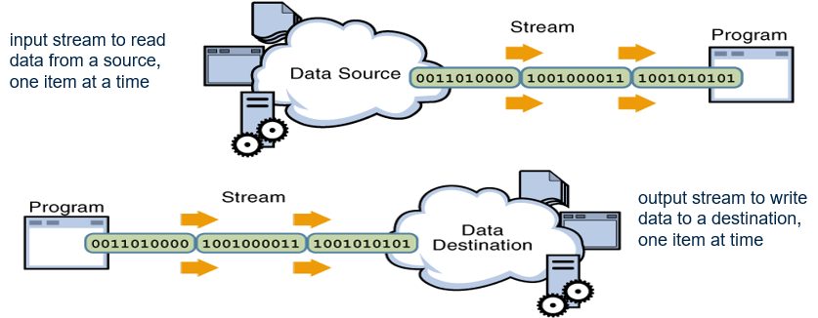
Types of Streams
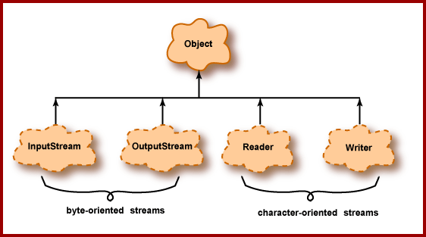
- Byte Streams: Handle I/O of raw binary data.
- Character Streams: Handle I/O of character data.
- Buffered Streams: Optimize input and output with reduced number of calls to the native API.
- Data Streams: Handle binary I/O of primitive data type and String values.
- Object Streams: Handle binary I/O of objects.
- Scanning & Formatting: Allows program to read and write formatted text.

Methods of I/O Stream
Methods of Input Stream | Methods of Output Stream
close, read | close, flush, write,

Predefined Streams
- System.out :refers to the standard output stream
- System.err :refers to standard error stream
- System.in : refers to standard input
Buffered Streams
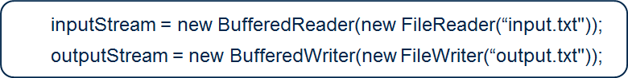
File Class
File class doesn’t operate on streams
Represents the pathname of a file or directory in the host file system
Methods of File Class :
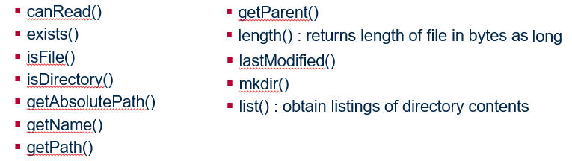

Java.io.Serializable
- Serialization is a process to read and write objects.
- It provides ability to read or write a whole object to and from a raw byte stream.
- Use object serialization in the following ways:
  - Remote Method Invocation (RMI): Communication between objects via sockets.
  - Lightweight persistence: Archival of an object for use in a later invocation of the same program.

